Proactive Project

# **Simulate Malware Execution & Detection :**

We are using a Windows 10 Enterprise Virtual Machine on Virtual Box



1. We had an incident that detected from Alerts that match threat hunting rule from our soc team tuned rules that reviewed & hardened as policy we have in our organization every 7 days.
2. Incident occurred from the user that violated the policy and installed file from untrusted sources that we defined before in our policy, because may be malicious and infect our machine then our network.
3. We receive alerts on our SIEM solution mainly from HIDS hosted on windows machine in our internal network.
4. Alert defines that machine interacts with malicious IP that match rule from tuned rules that we had written for hunting malware and suspicious actions on network machines.
5. Soc team receive alert from the Suricata HIDS Dashboard that we create before for more visibility

About actions that acted on our network.

1. Dashboard alert that we detect the incident from:

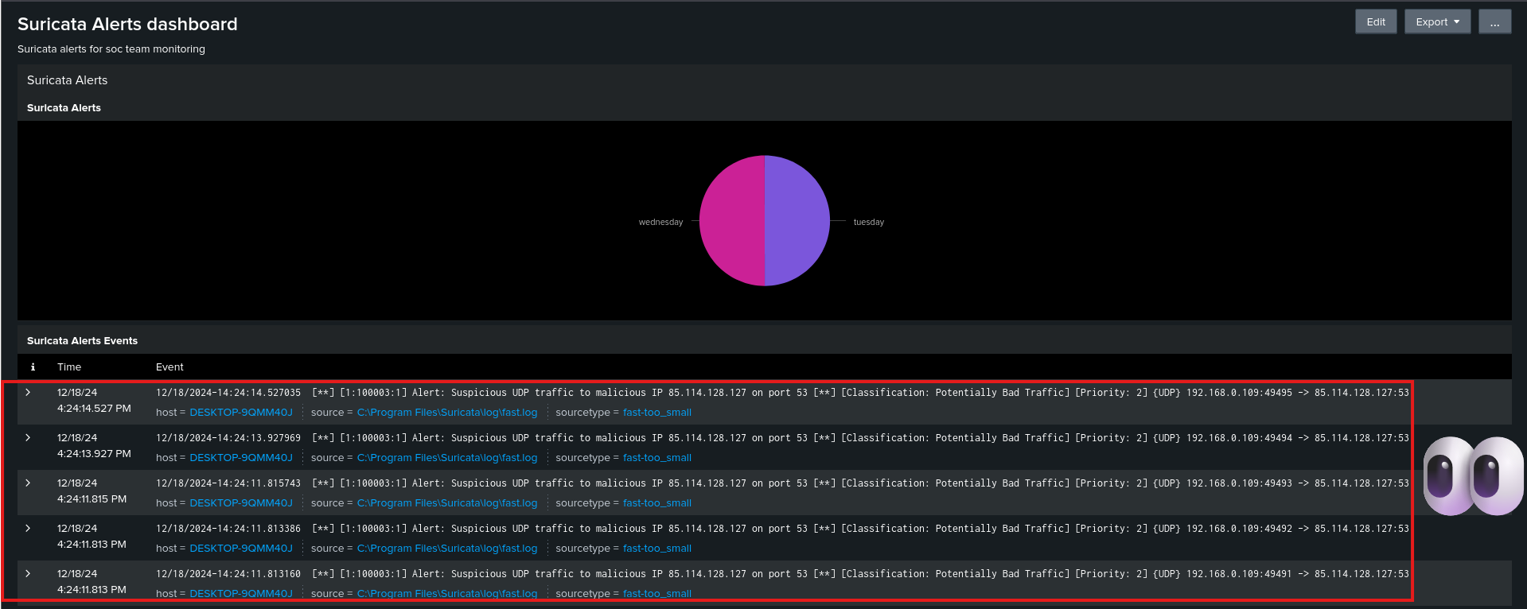

1. The Geo map for destination Ips that our machines interacted with in the world Heated map:

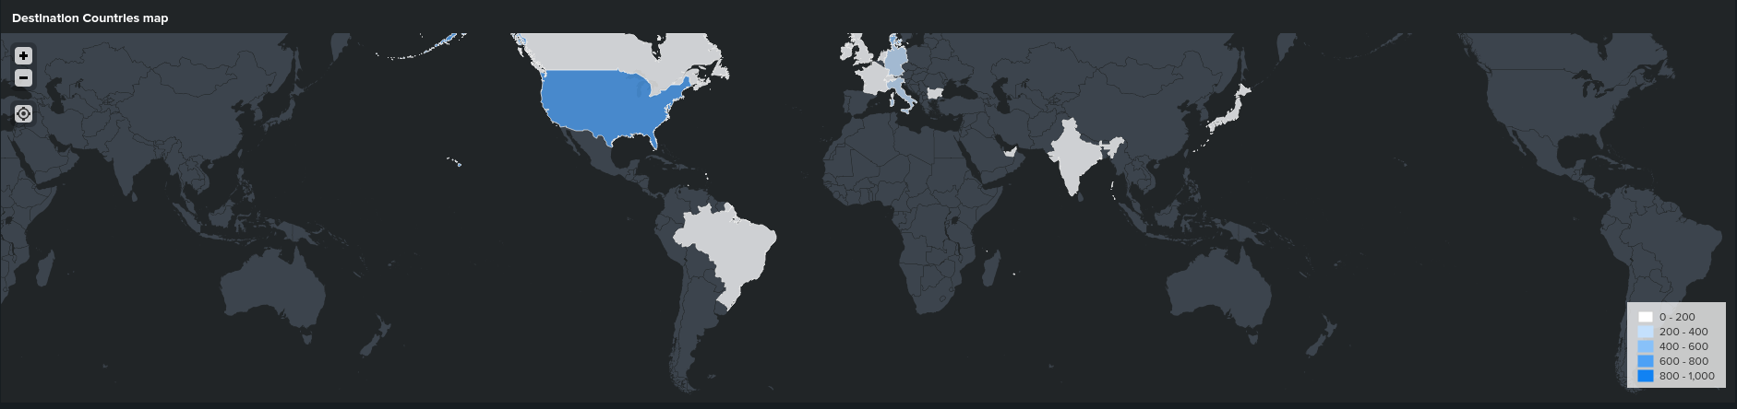

1. Our team hunt also massive amount of data transmitted to north America, mainly that not legit from base line that we define in our policy.



# **Start investigation for suspicious activity that we get from Suricata alert:**

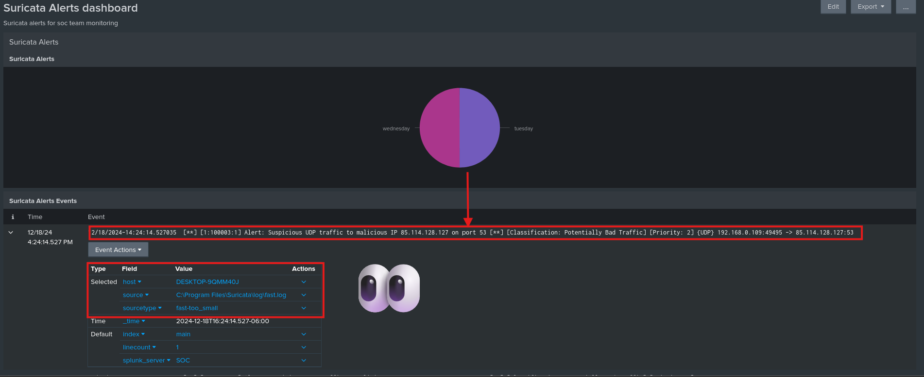

1. From our alert that fired from malicious activity we detect the machine that cause that action (**DESKTOP-9QMM40J**) 🡺 thar will be the root cause of the incident until we prove that that alert is false positive.
2. Start retrieve all event logs that relate to the machine that fire that alert.

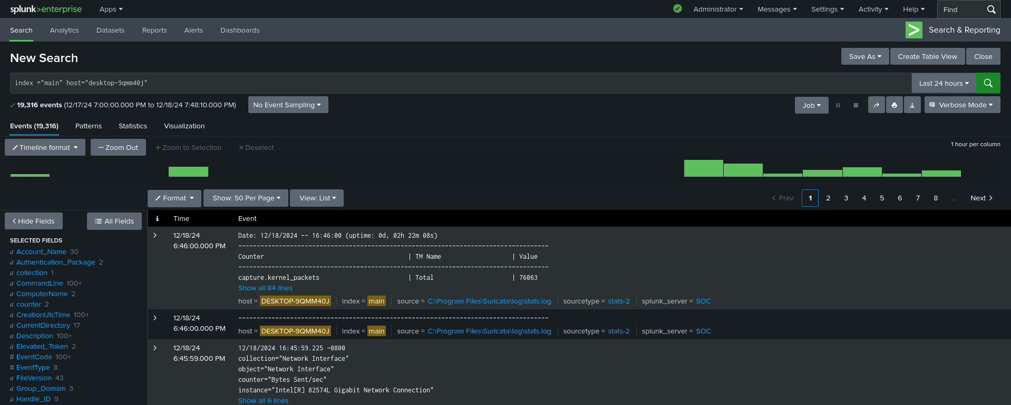

1. Get our sources that machine depnds on to push logs to our management node (SIEM).

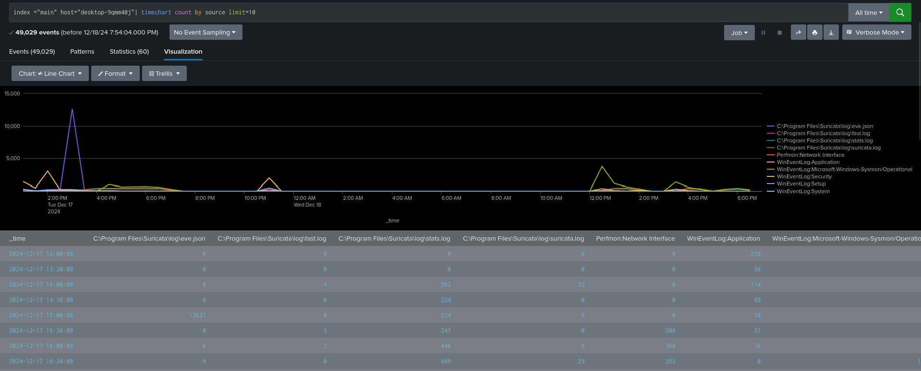

1. We must focus on specific log source to get tuned logs to detect the importance of the alert we

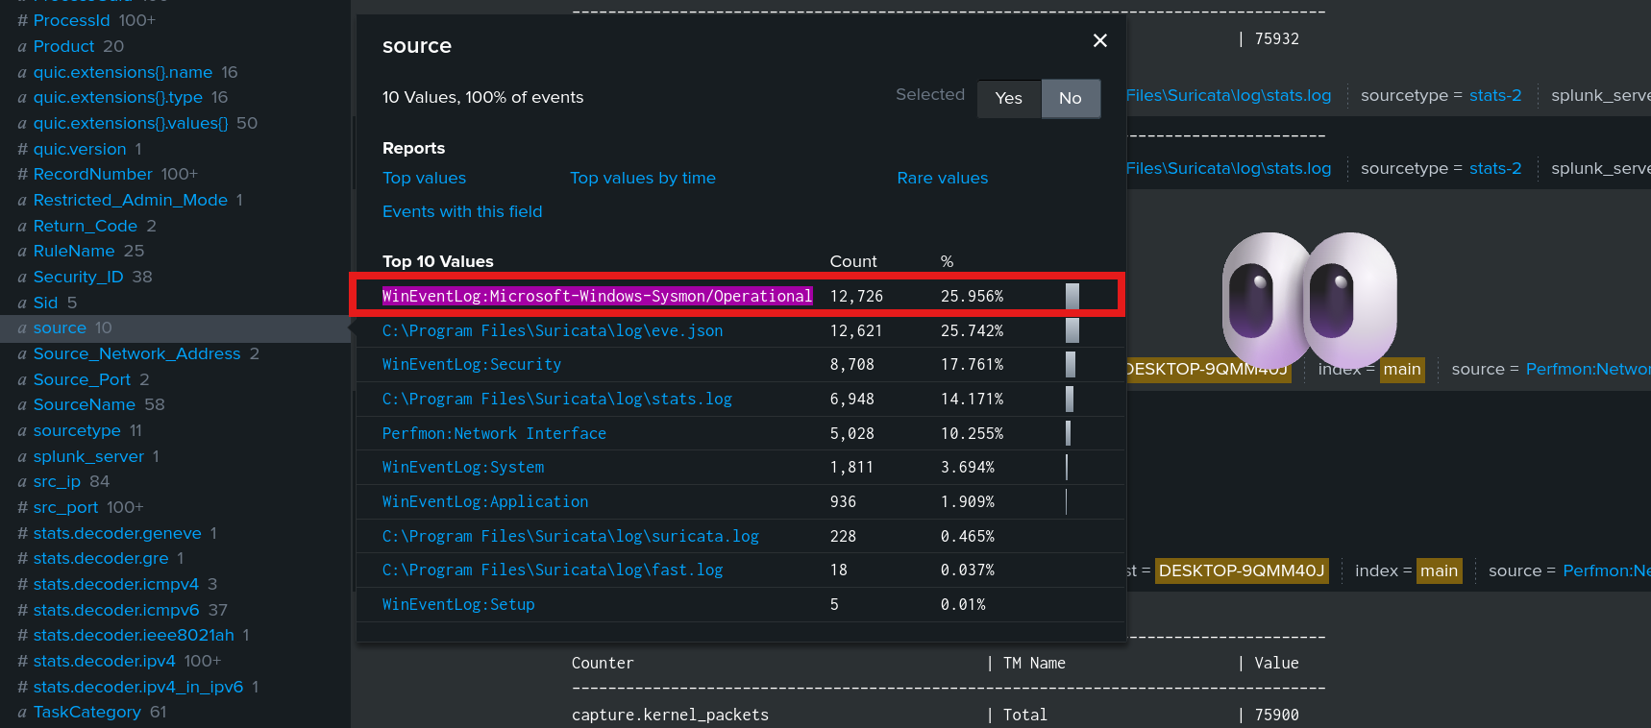

1. We get all events that Sysmon log Source hunt from the infected machine and push throw universal forwarder.

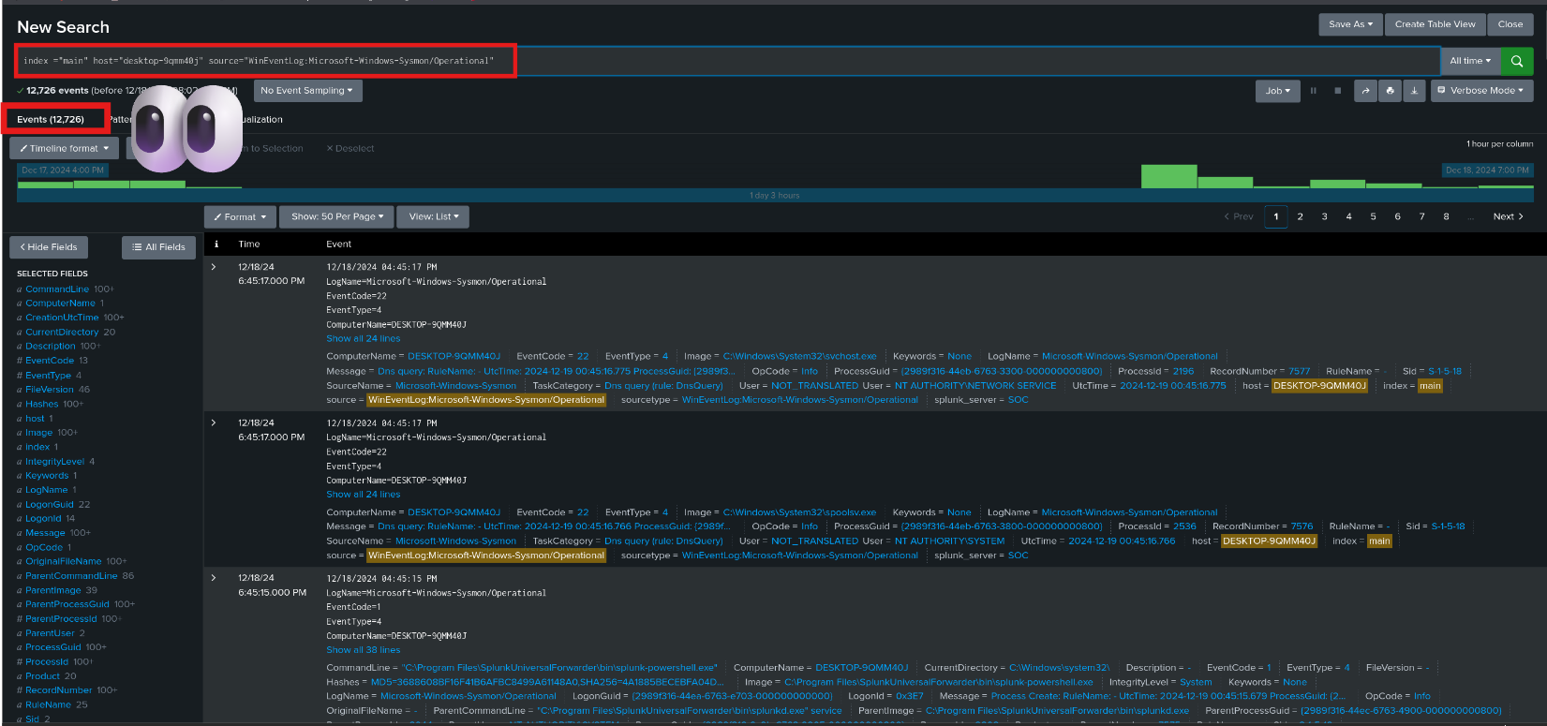

1. We must tunning our search query to get more information about the exact alert related events,

So, we limit the time interval to get the least number of events to investigate into.

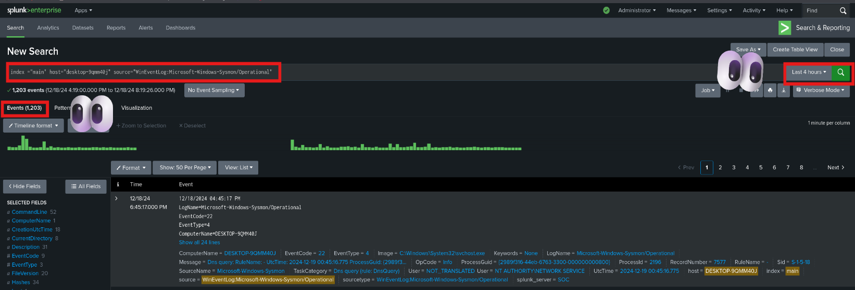

1. We focus on processes that created by the machine user (**saber**) to be more knowledgeable about action that user took, then we hunt specific process with bad extension for obfuscation security controls of the organization ( **.pdf.exe** ) .

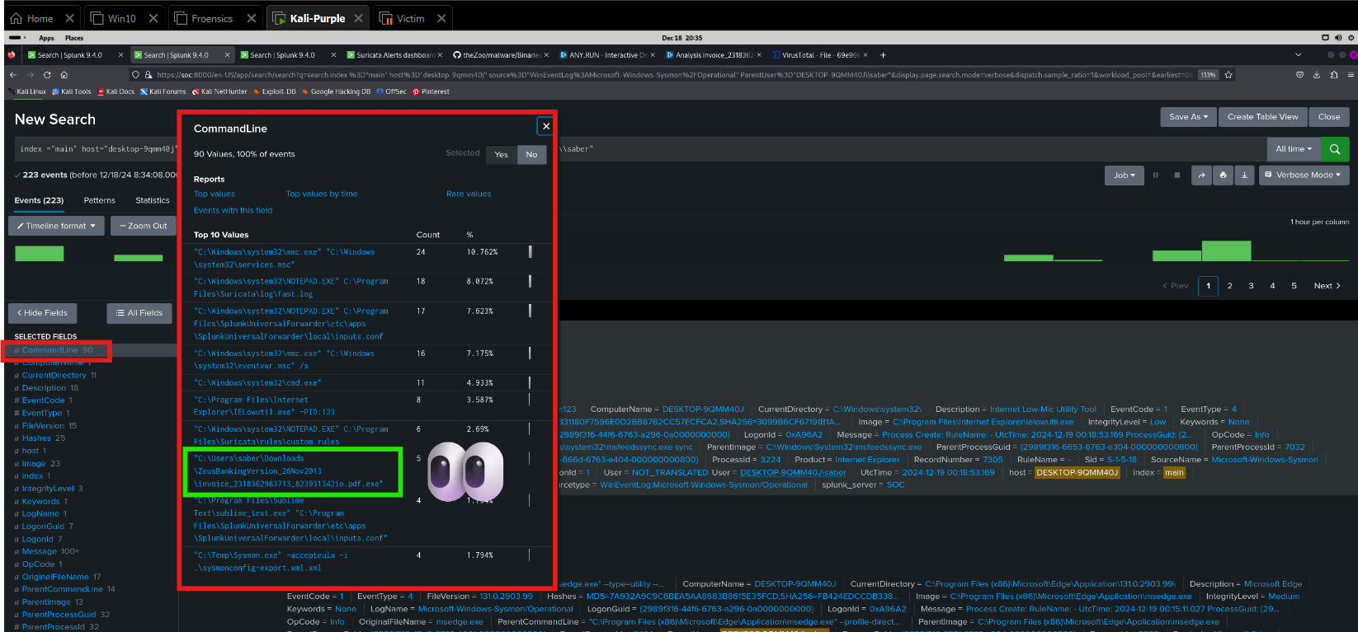

1. We must investigate more depth with events related to that process to be insightful with details the Sysmon monitoring services provide, so we get 5 events we must be careful in that events investigation.

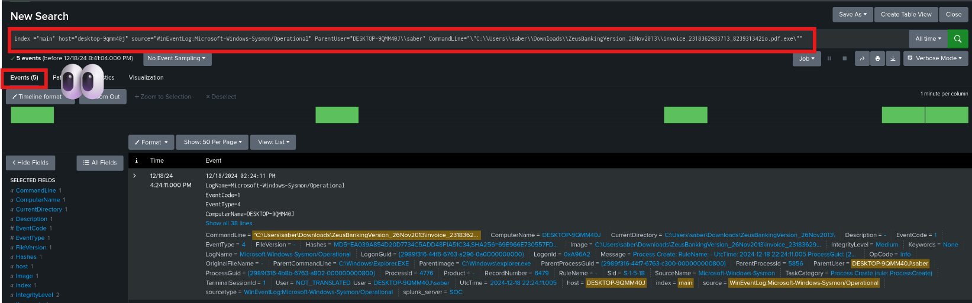

1. From Sysmon features the service of calculate the hash for the process that created and files that the user modified or accessed, that add insightful information for analysts to detect which file be malicious or not with the use of Threat Intel tools like Virus Total that will be used in our investigation.

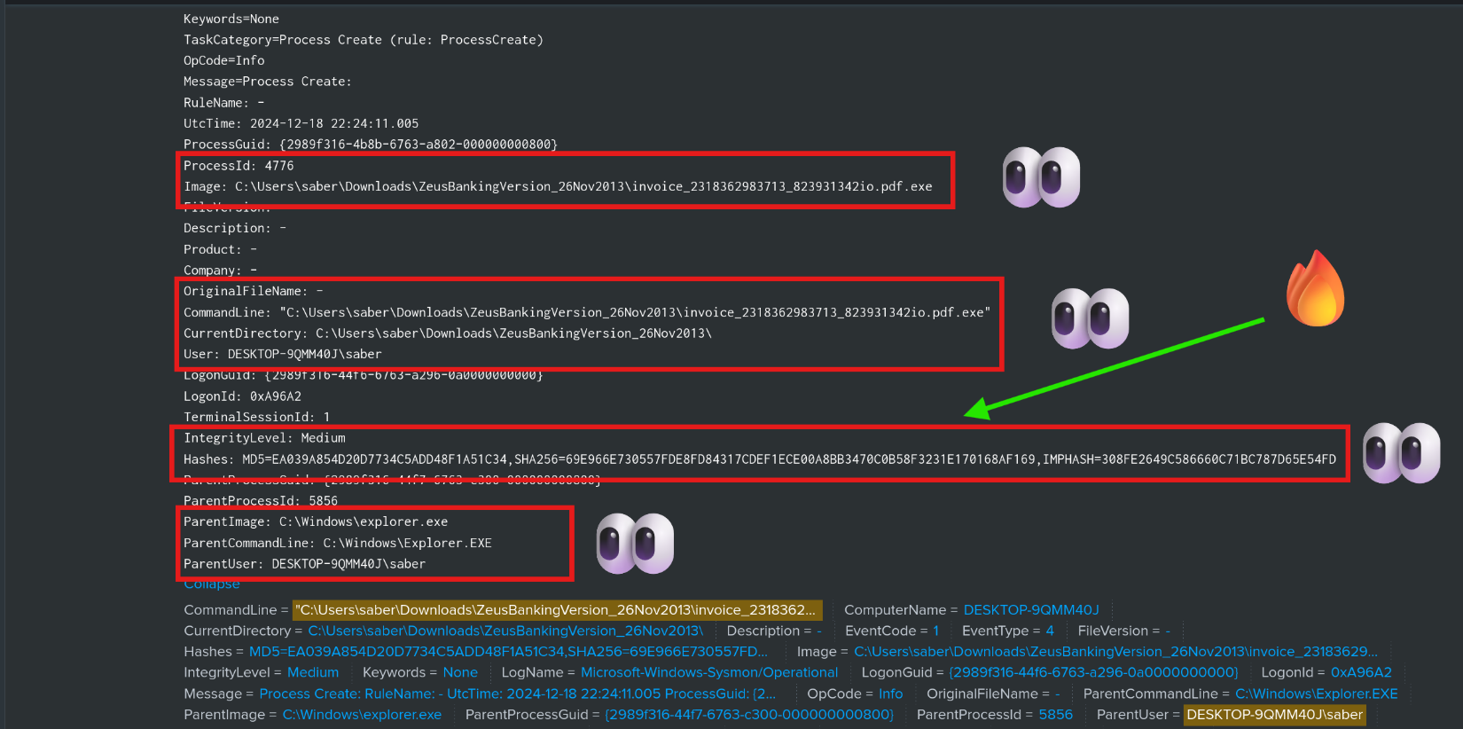

1. Mainly from event that Sysmon pushed to SIEM, we have the file (**invoice_2318362983713_823931342io.pdf.exe**) recorded and its relevant information like Hash with many algorithms.

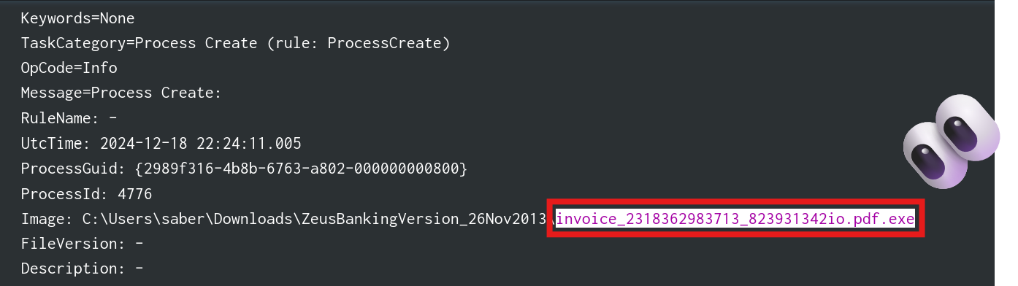

1. Get that file hash to be investigated in our Threat Intel (**Virus Total**)

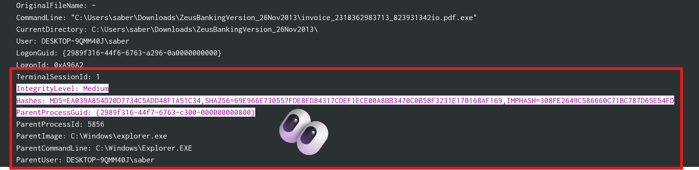

1. Investigate the hash on our Threat intel VT:

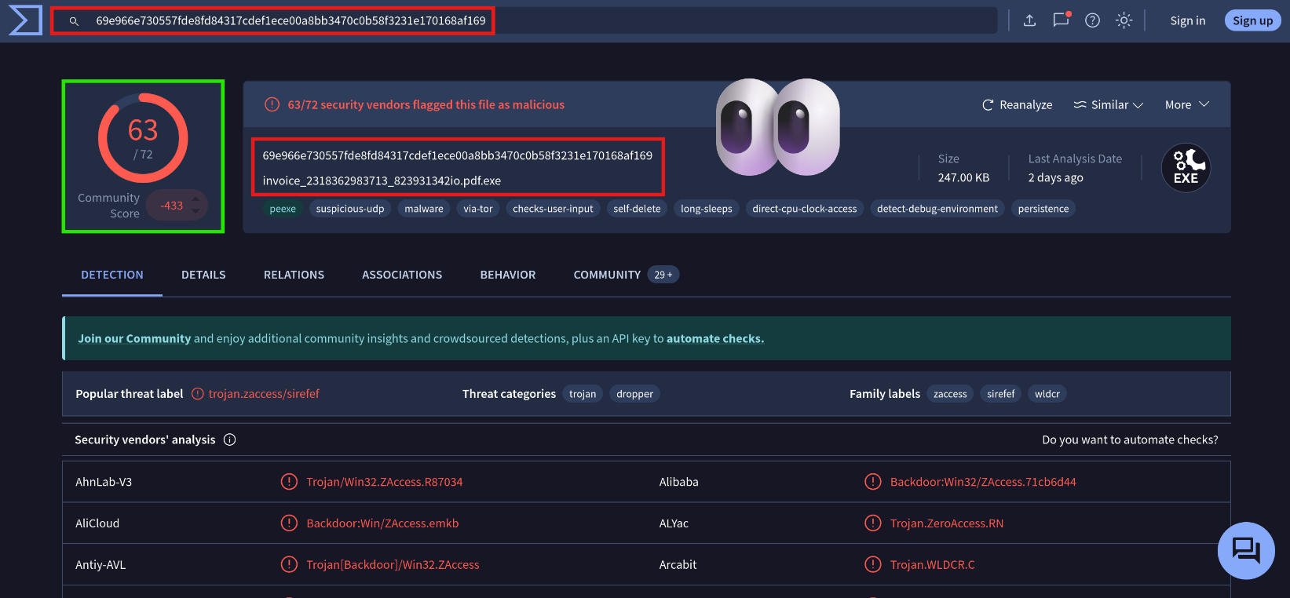

1. The analysis of the file **invoice_2318362983713_823931342io.pdf.exe** with the hash **69e966e730557fde8fd84317cdef1ece00a8bb3470c0b58f3231e170168af169** revealed it to be highly malicious. Detected by **63 out of 72 security vendors**, it is categorized as a **Trojan** and identified with labels such as **ZAccess**, **Sirefef**, and **WLDRC**. This file exhibits behaviors like persistence mechanisms, suspicious UDP activity, and anti-debugging techniques, indicating a sophisticated threat capable of maintaining access and evading detection.
2. The detection of this file highlights the importance of proactive threat detection and response mechanisms, including file analysis, endpoint monitoring, and the implementation of strict email and file download security controls. This threat should be considered highly dangerous, and additional steps, such as blocking the hash and related domains, should be taken to prevent further incidents.
3. This results from threat intel that prove true positive incident in our network, and we must create ticket in Incident Management Agent to move to the next stage (**Incident Response Process**).
4. Incident response process that will be executed for recovering system to the normal mode is:

**1. Preparation**

This step involves setting up processes, tools, and resources to ensure an organization can effectively respond to incidents.

**Key Actions:**

* Develop and document an **Incident Response Plan (IRP)**.
* Establish an **Incident Response Team (IRT)** with defined roles and responsibilities.
* Deploy and configure security tools like SIEMs, EDRs, and firewalls.
* Train staff with **cybersecurity awareness** and conduct regular incident response drills (e.g., tabletop exercises).
* Maintain an updated **inventory of critical assets** and their associated risks.
* Develop playbooks for common attack scenarios (e.g., phishing, ransomware, data breaches).

**2. Identification**

In this phase, you detect and confirm potential security incidents by analyzing alerts, logs, and behaviors.

**Key Actions:**

* **Monitor systems** and networks using tools like SIEM, IDS/IPS, and endpoint security tools.
* Analyze alerts and anomalies to confirm if an incident is occurring.
* Gather forensic data, including logs, system snapshots, and network traffic.
* Classify and prioritize the incident based on its severity, impact, and type (e.g., phishing, ransomware).
* Answer critical questions:
  + What happened?
  + When did it occur?
  + Who/what is impacted?
  + What is the potential impact?

**3. Containment**

This step focuses on stopping the spread of the attack and limiting its damage.

**Key Actions:**

* **Short-term containment**: Isolate affected systems (e.g., unplug from the network, disable accounts).
* **Long-term containment**: Set up temporary solutions, such as deploying new firewalls or network segments.
* Block malicious domains, IPs, and email addresses in firewalls or DNS settings.
* Implement patches or workarounds to prevent further exploitation.
* Preserve evidence for further investigation (e.g., disk images, memory dumps).

**4. Eradication**

In this phase, you remove the threat from your environment to prevent further compromise.

**Key Actions:**

* Identify and remove malware, backdoors, or malicious files.
* Patch exploited vulnerabilities in systems, software, or configurations.
* Scan systems thoroughly to ensure no remnants of the attack remain.
* Harden systems and networks against similar attacks in the future.

**5. Recovery**

The goal of this step is to restore normal operations while ensuring the environment is secure.

**Key Actions:**

* Rebuild or restore affected systems from clean backups.
* Verify that all systems are functioning properly and securely.
* Monitor systems closely for any signs of lingering threats.
* Gradually reintroduce affected systems to the network.

**6. Lessons Learned**

This final phase involves reviewing the incident to improve future responses and strengthen defenses.

**Key Actions:**

* Conduct a **post-incident analysis** with the incident response team.
* Document the root cause, timeline, response steps, and outcomes in an **incident report**.
* Update the Incident Response Plan (IRP) and playbooks based on lessons learned.
* Implement additional security measures, such as stronger policies or better tools.
* Share findings with relevant stakeholders to promote awareness and understanding.

1. Sysmon service that we rely on in the incident we have on our infected machine .



1. Suricata service that we rely on in the incident we have on our infected machine that work as Host-based IDS for more visibility on each machine.



1. Splunk forwarder service that we rely on in the incident we have on our infected machine that works as forwarder of logs from all sources we need to ingest into our SIEM.



1. Network diagram for machines we have in our network that detect that attack from infected machine.

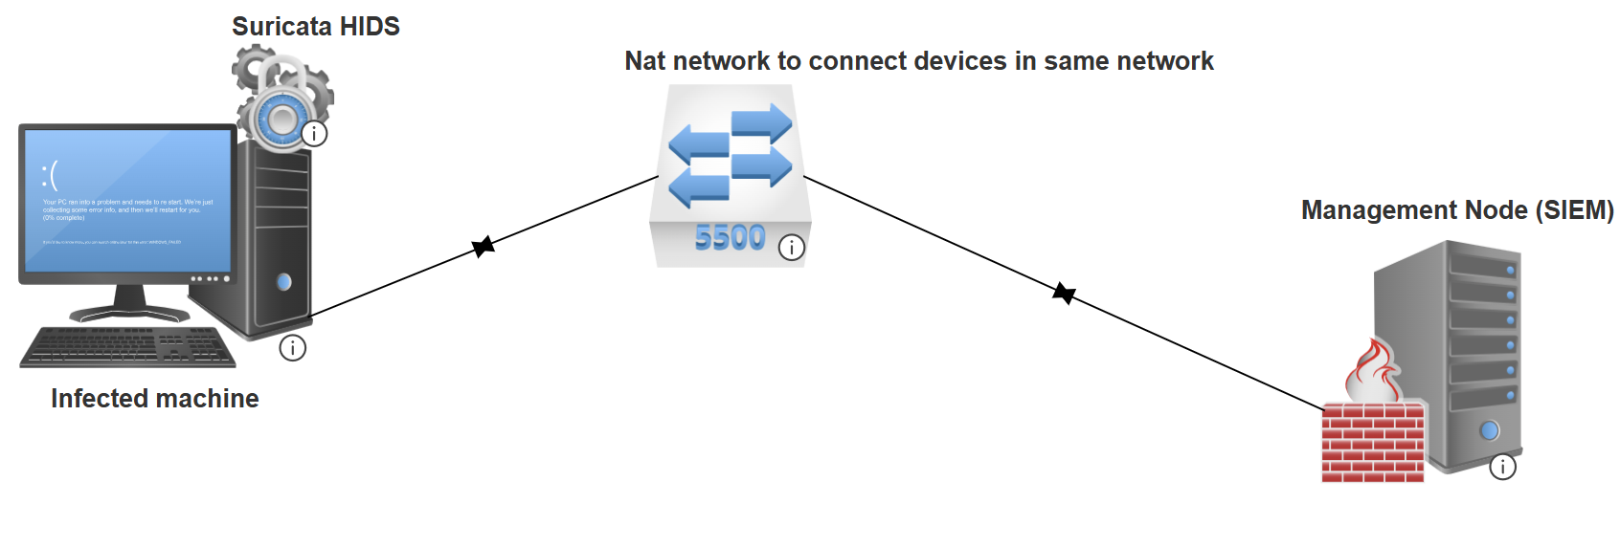

1. Suricata rule that hosted on infected machine that hunt the malicious file when executed and interact with malicious DNS server.

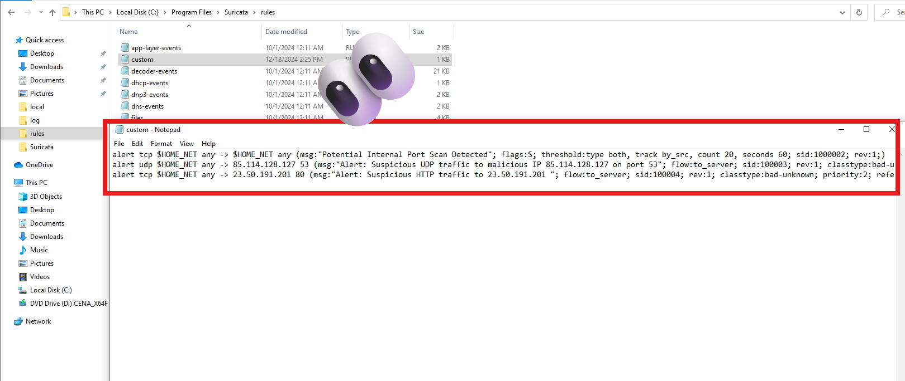

**Malware analysis with sand Boxing (Any Run) for incident response process followed the organization policy:**

* + 1. **Once we upload the executable file that caused the incident and affect our system and infect the machine by the user (Saber) that download the malware and run it on the machine.**
    2. **The machine directly infected by running the malware we upload, the malware run on the machine and create sup-Processes to enforce the persistence on the machine and directly remove itself.**

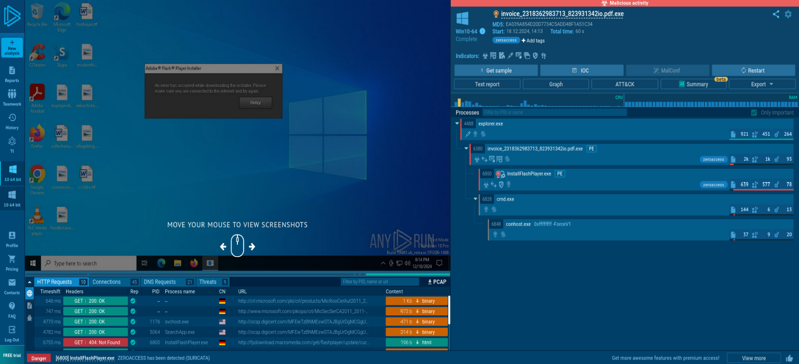

* + 1. We hunt all Http Requests from all processes that created from the parent to all decedent processes to get html document from servers that malicious processes interacted with them before.

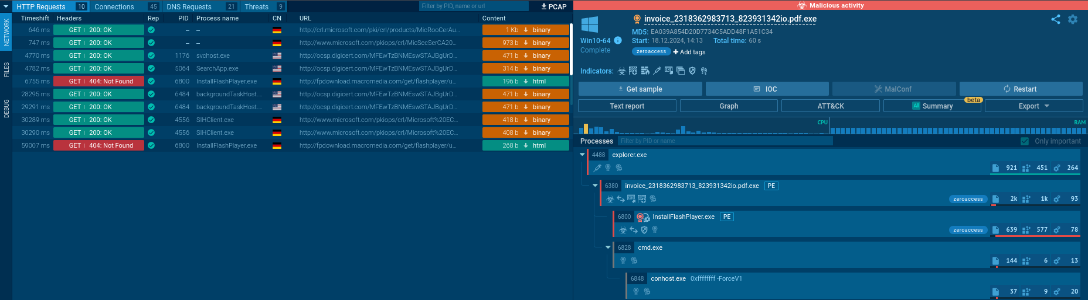

* + 1. Get all connection that all processes with both ( **TCP & UDP** ) connection for all application layer protocols that run with mal-processes.

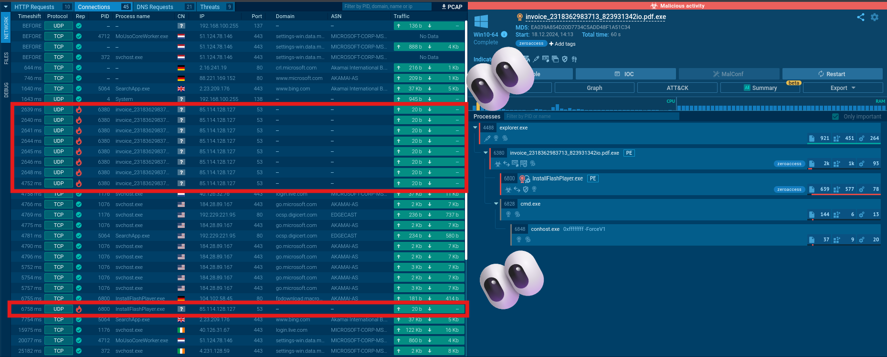

* + 1. Get all DNS records that all processes resolve the names to IPs.

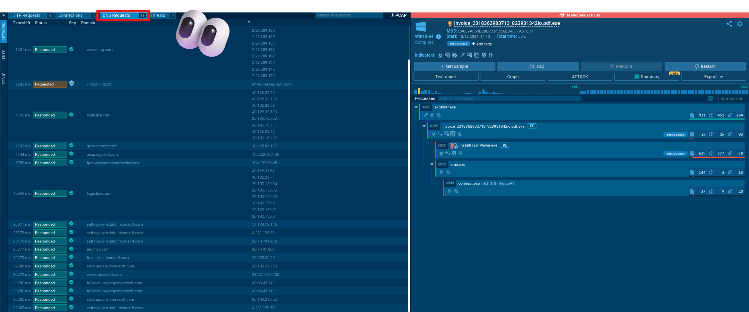

* + 1. Get all threats that the Sandbox detect from the dataset of IOCs for hunt threats of the malicious files.

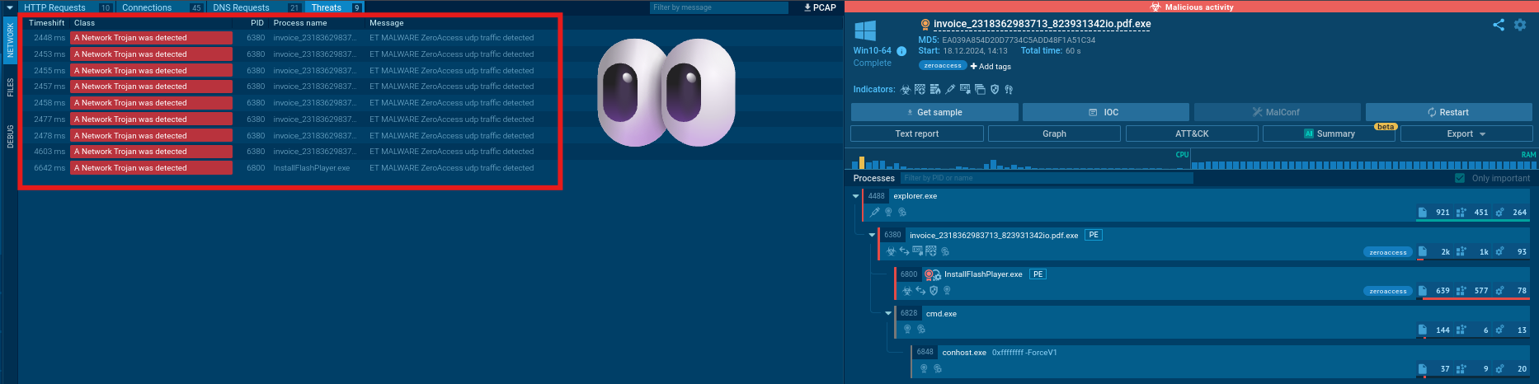

* + 1. Sandbox marks the **InstallFlashPlayer.exe as the most malicious process created from the malicious process installed by Saber-User.**

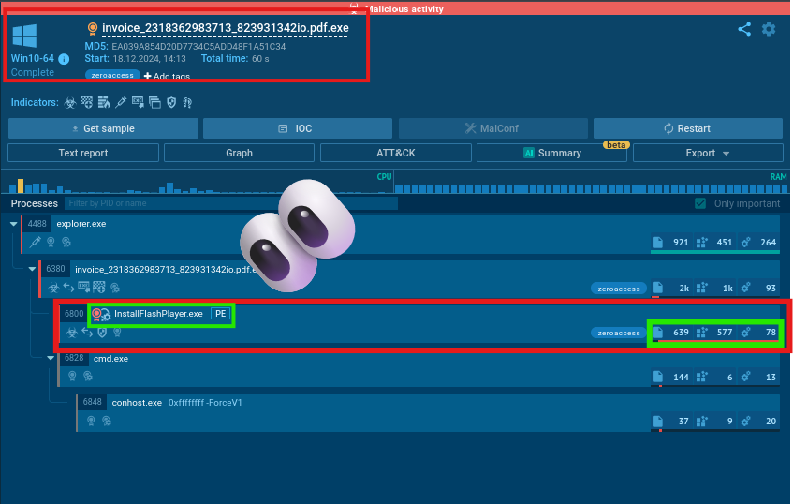

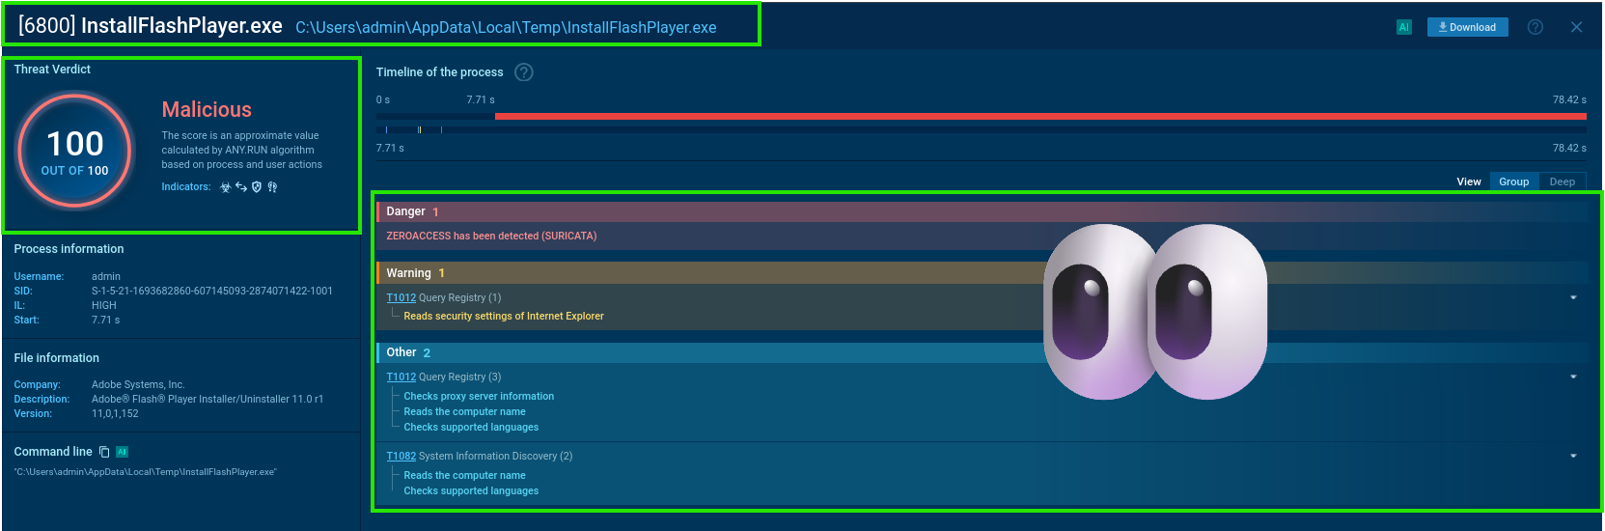

* + 1. The process that marked 100% malicious process, this process modify files to execute persistence for more information about the network to execute letteral movement on the network and infect more devices to steal credentials of whole network.

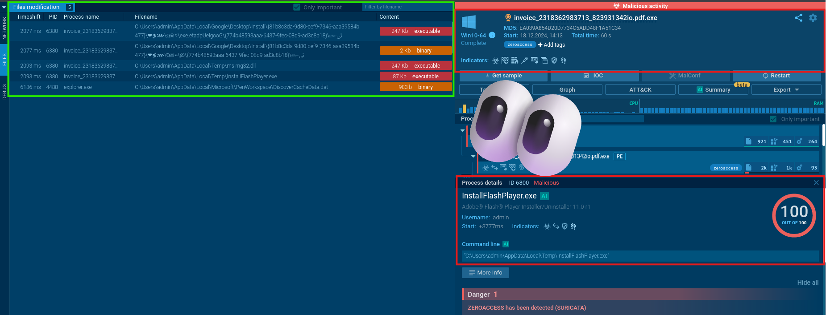

* + 1. At this context we have to start Eradication process to remove all infected files from the machine and recover the system to normal state.
    2. Lesson learned from that attack is to harden the policies on the users more and more to ensure the users do not violate the rules for further security complexity.
    3. We have IOCs that we get from the incident:

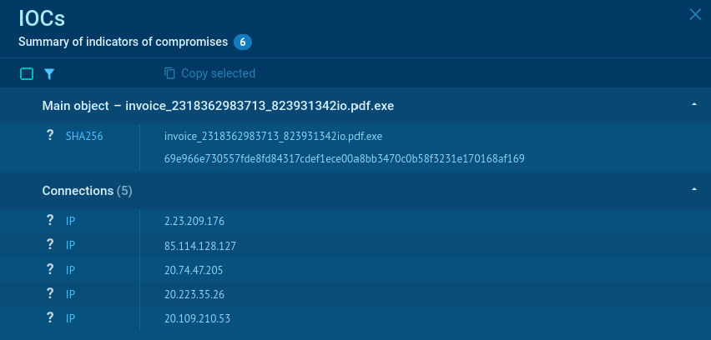

* + 1. Next step that we must create further hunting rules for the HIDS and machine’s firewall to ensure security patches in our network and simulate the attack for proactive security.
    2. After the incident response process that we trigger on the infected machine we recover the system to normal state.



**Memory dump investigation with Volatility & Yara Rules**

**Volatility 2**

At first, I used “imageinfo” to show information of this dump

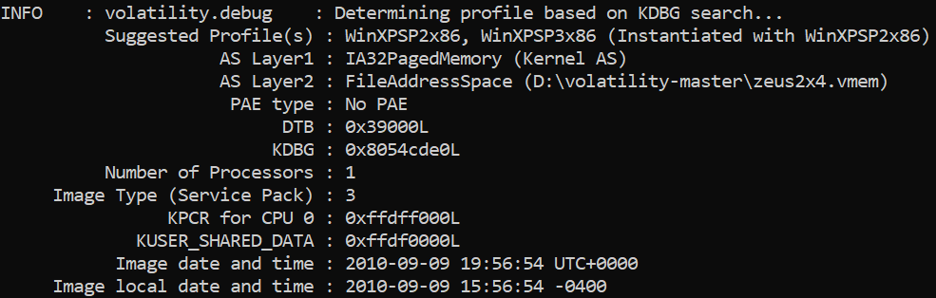

We’re going to use the “WinXPSP2x86” profile in the following steps. Let’s then start by showing process list using “pslist”.

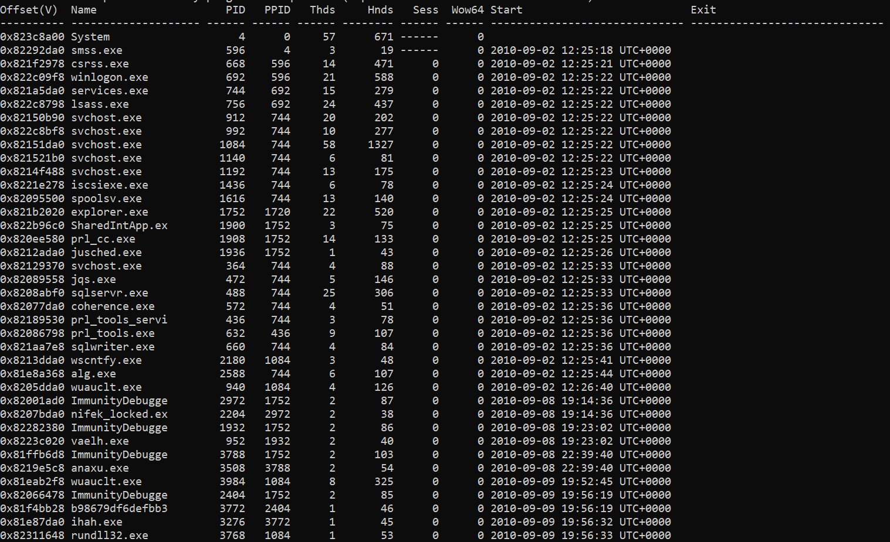

By looking at the process we can see that some are legit like “explorer.exe”, “winlogon.exe”, “services.exe”, and so on. But some of them look suspicious, like “b98679df6defbb3”, and with the existence of “ImmunityDebugger” we can guess that there was some sort of analysis running there. Let’s look further into these processes. I am going to look for processes that was run by ImmunityDebugger. There are multiple instances of it so we’re going through each one.

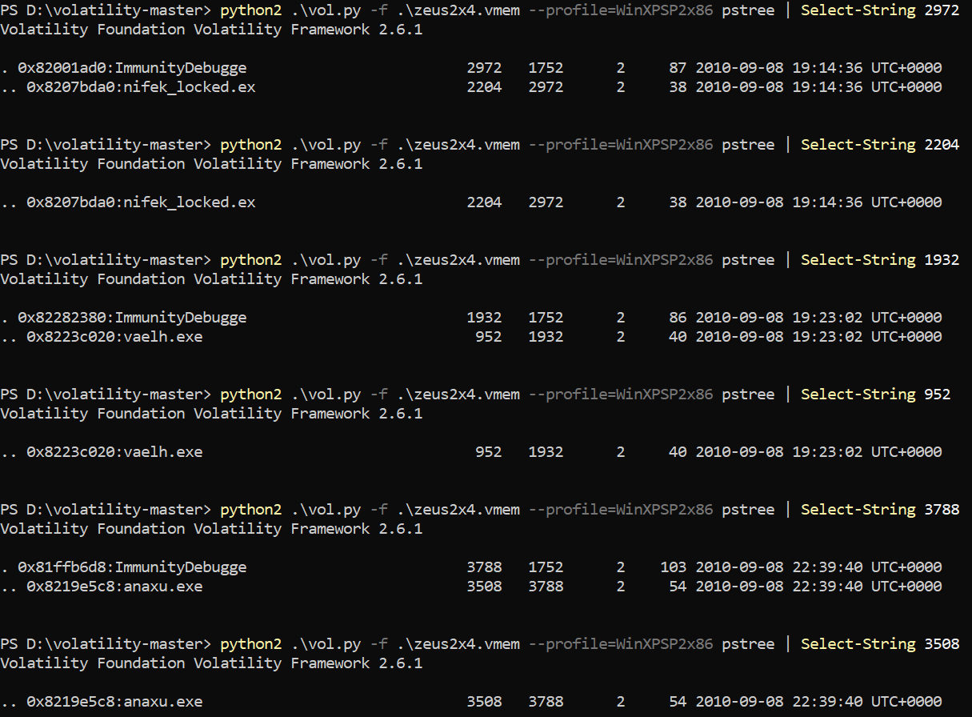

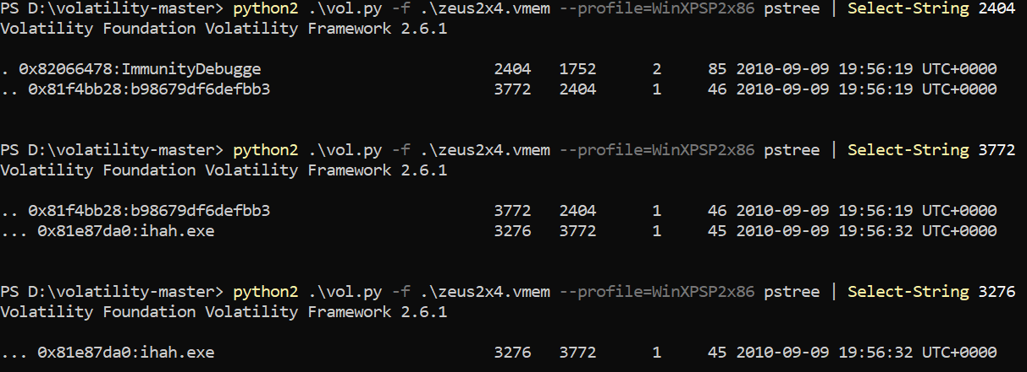

As we can see above, there are some suspected files in this case “nifek_locked.ex”, “vaelh.exe”, “anaxu.exe”, “b98679df6defbb3”, and “ihah.exe”. Next step, we’re going to use “filescan” to look for these files.

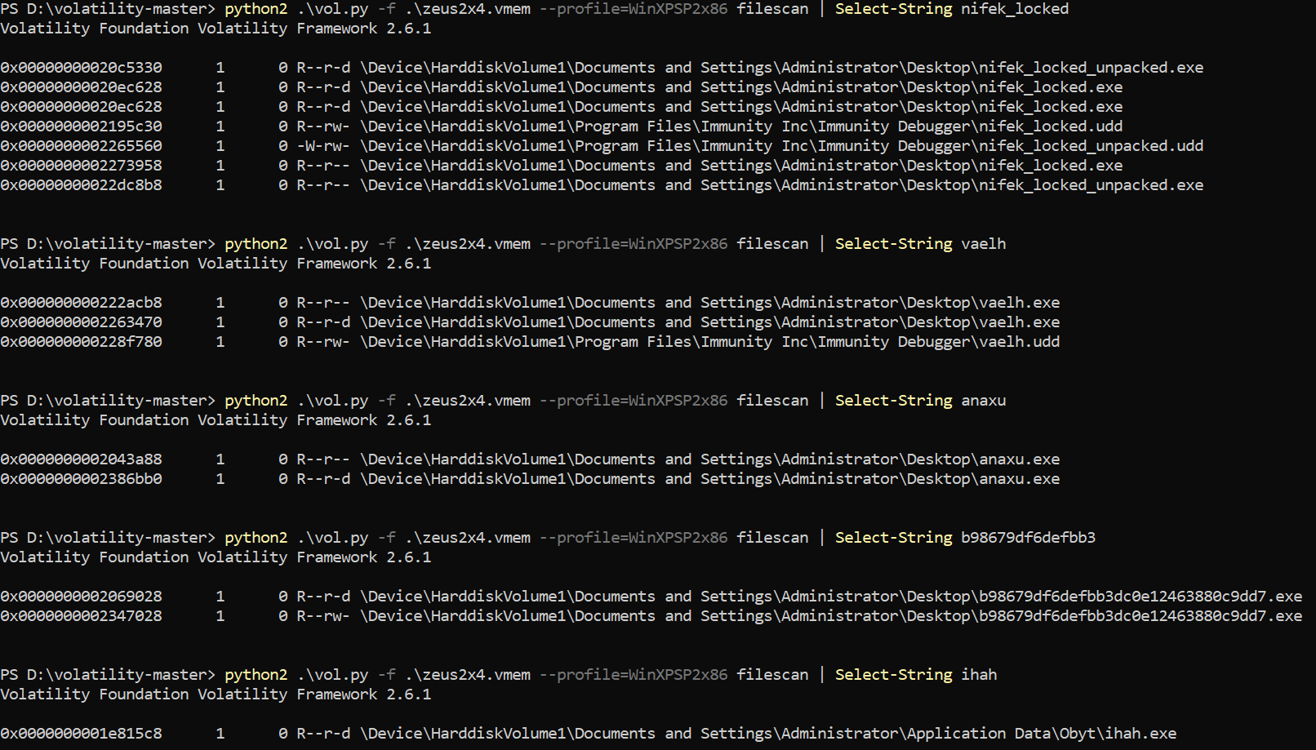

From the point of view, we can’t really tell if they are malicious or not. But, by observing the “b98679df6defbb3”, we can see here that it seems to be a hash digest. So, let’s pass it to Virus Total and look for any suspicion. And it’s indeed malicious with score 46/54.

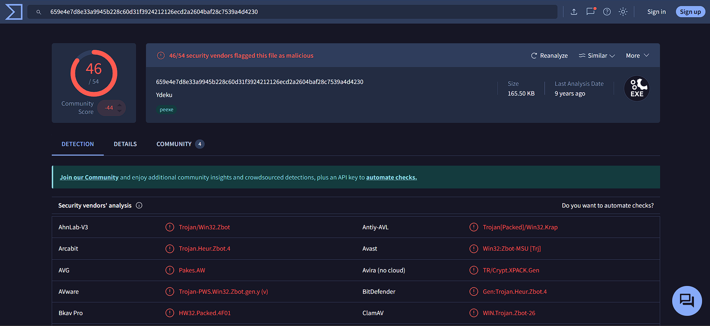

Now I’m going to look for information about this file through “handles” module.

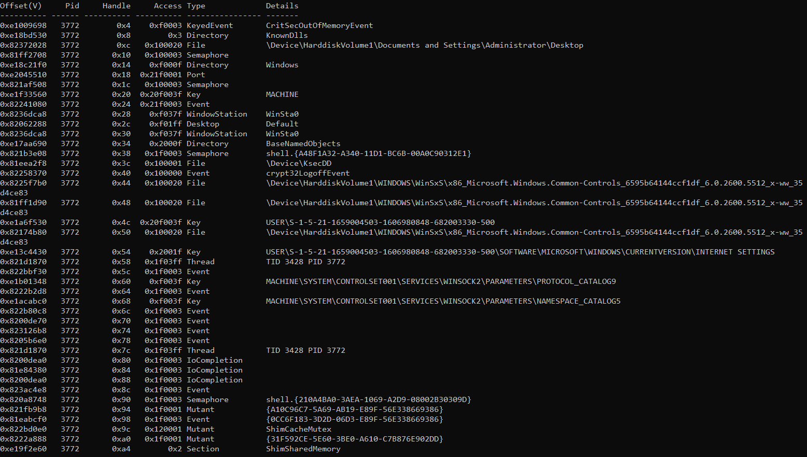

As we can see, the “MACHINE\SYSTEM\CONTROLSET001\SERVICES\WINSOCK2\PARAME

TERS\PROTOCOL_CATALOG9” can be an indicator of some kind of network interaction. Let’s run “connscan” and see if we can find any suspicious IP addresses.

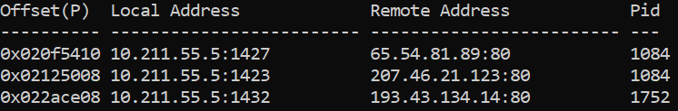

Here we can see that there are three IP addresses, two of them is associated with Pid 1084 which is svchost service, and the last is associated with Pid 1752 which is explorer. Let’s use scamalytics to see if they indicate any risk.

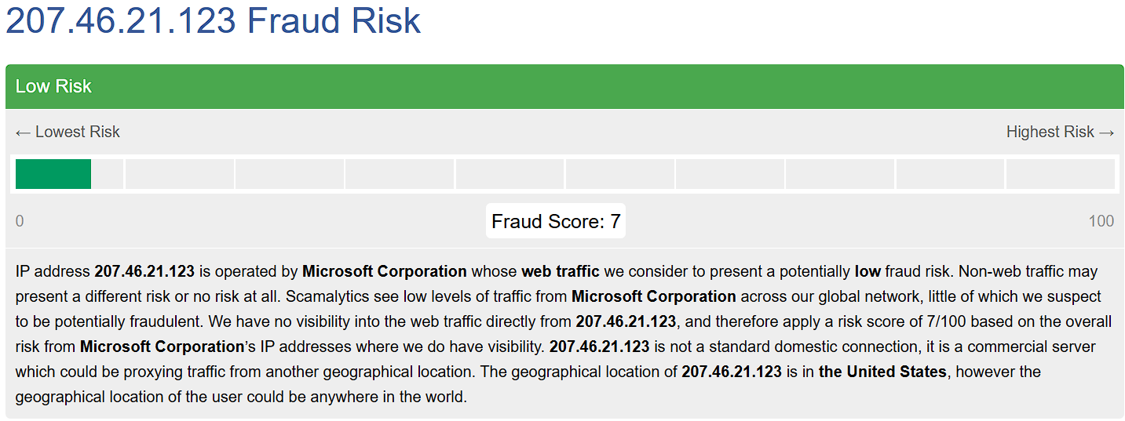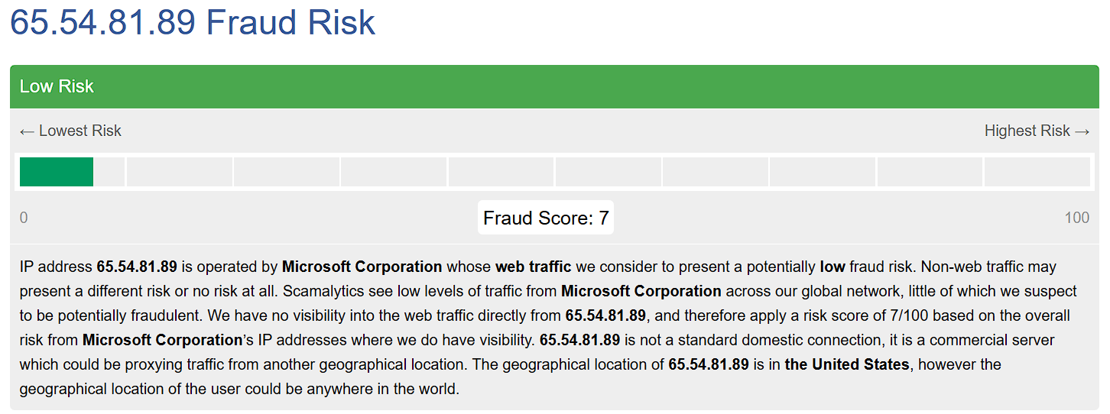

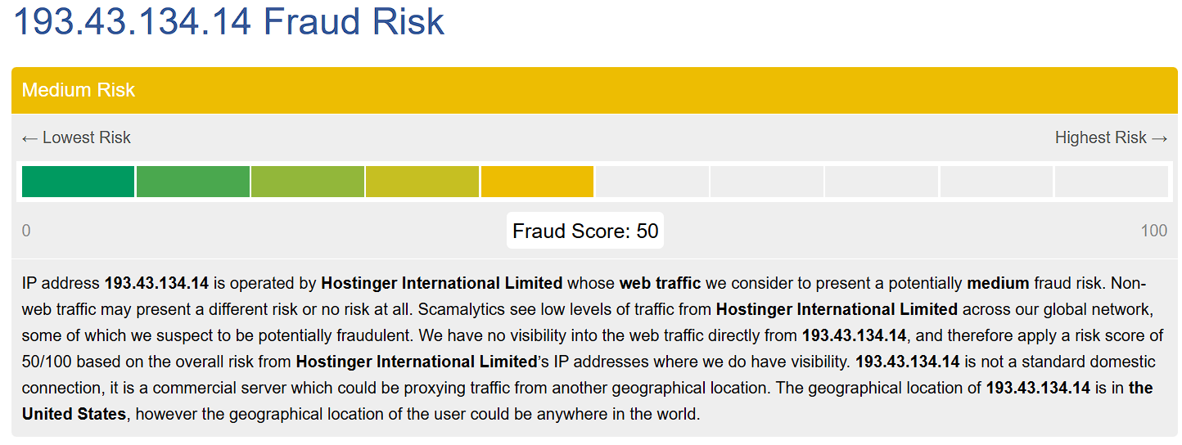

It looks like “193.43.134.14” has a medium fraud score, let’s pass it to virus total just to make sure that we are on the right track.

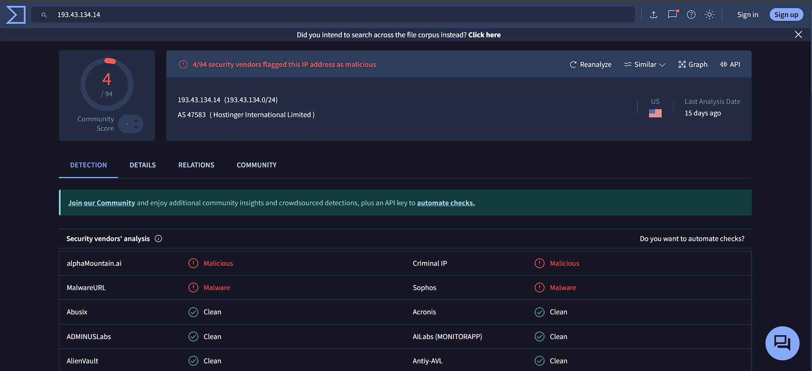

Now, we can conclude that this IP is malicious according to Virus Total. If we navigate to the Relations tab, we’ll see the following

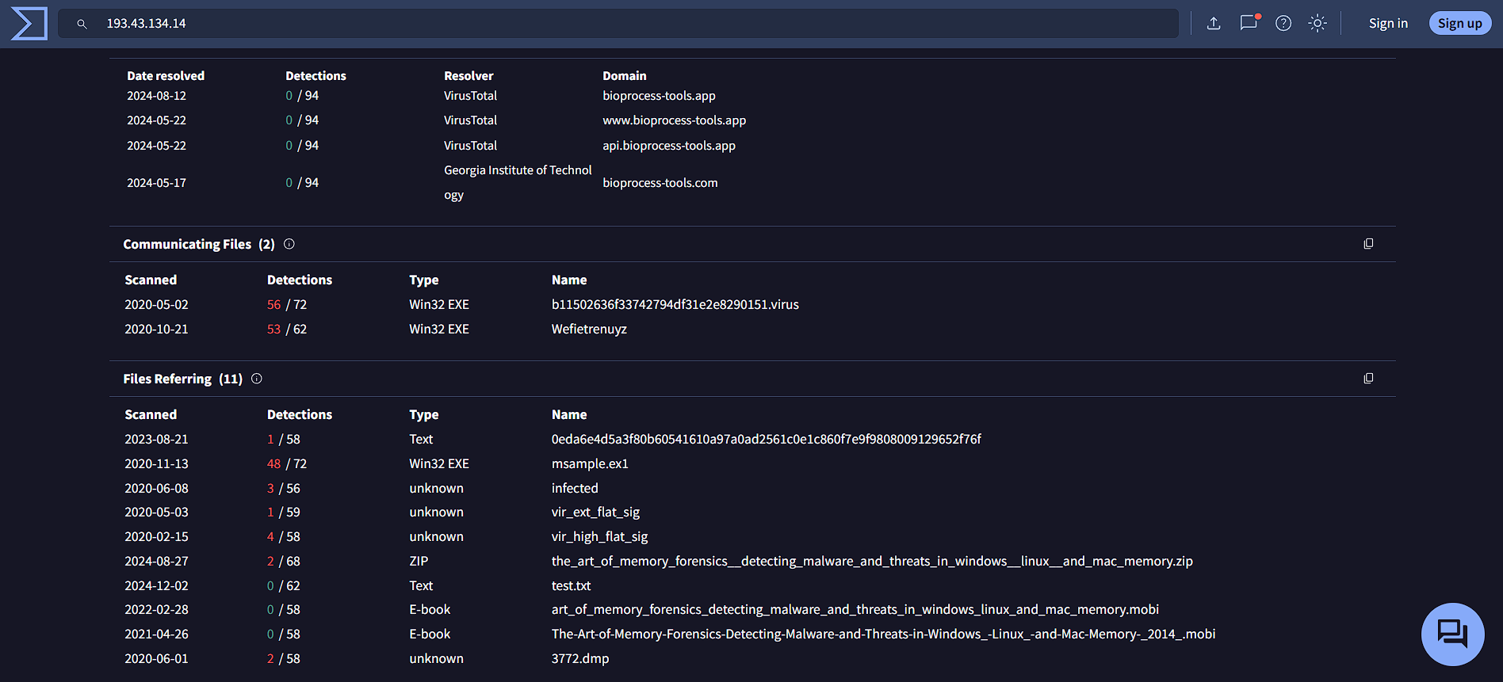

One of the files-Referring is 3772.dmp which is the process’s ID, the other is Wefietrenuyz which if we look back at the malicious file’s details, we’ll see it there.

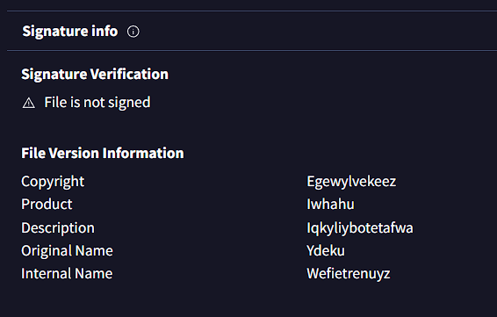

Now let’s dump the suspicious processes and see if we can find anything interesting.

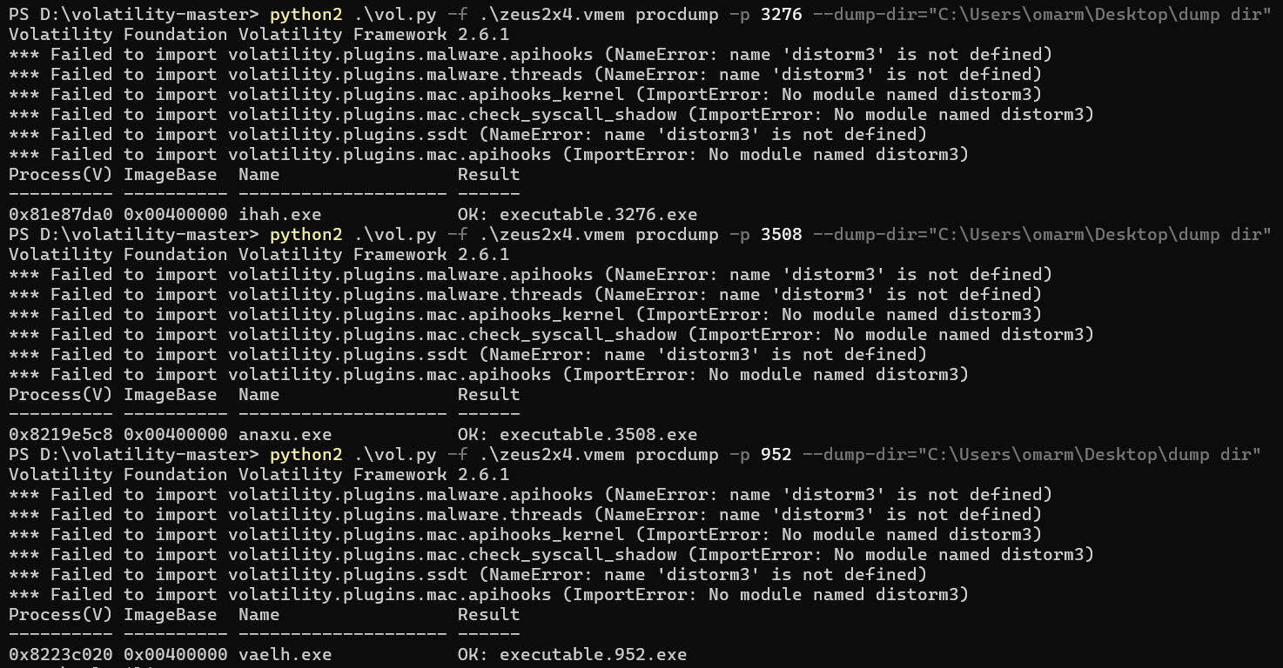

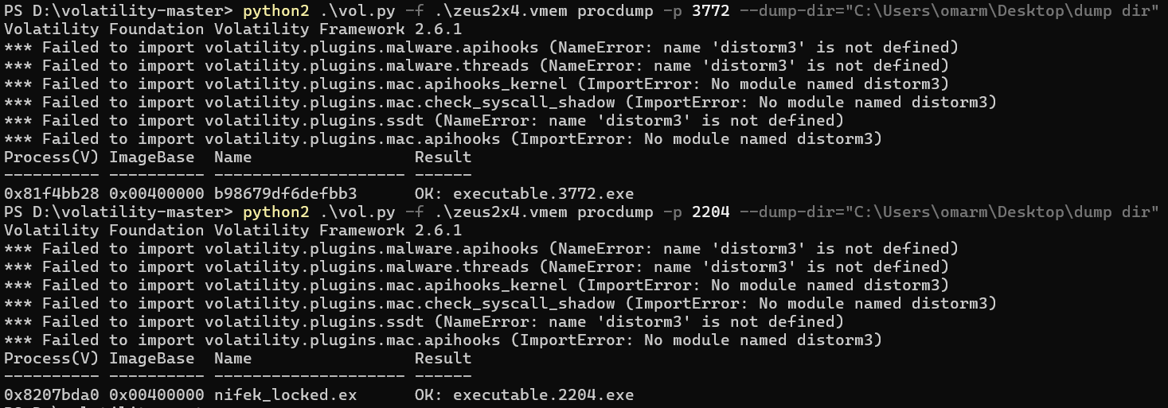

I’ve transferred them to my kali linux machine and made a directory for each one with the name of one directory as one process’s name.

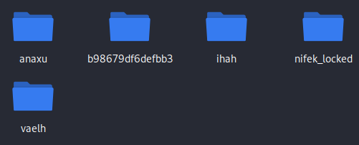

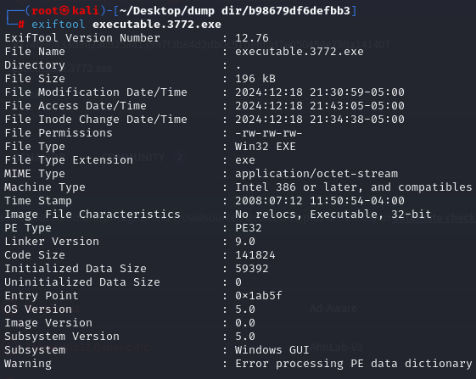I’ve tried using tools like exiftool, binwalk, pedis, and others. And I couldn’t resolve errors associated to these tools.

We can pass these dump files to virus total and see if they indicate to any malicious content.

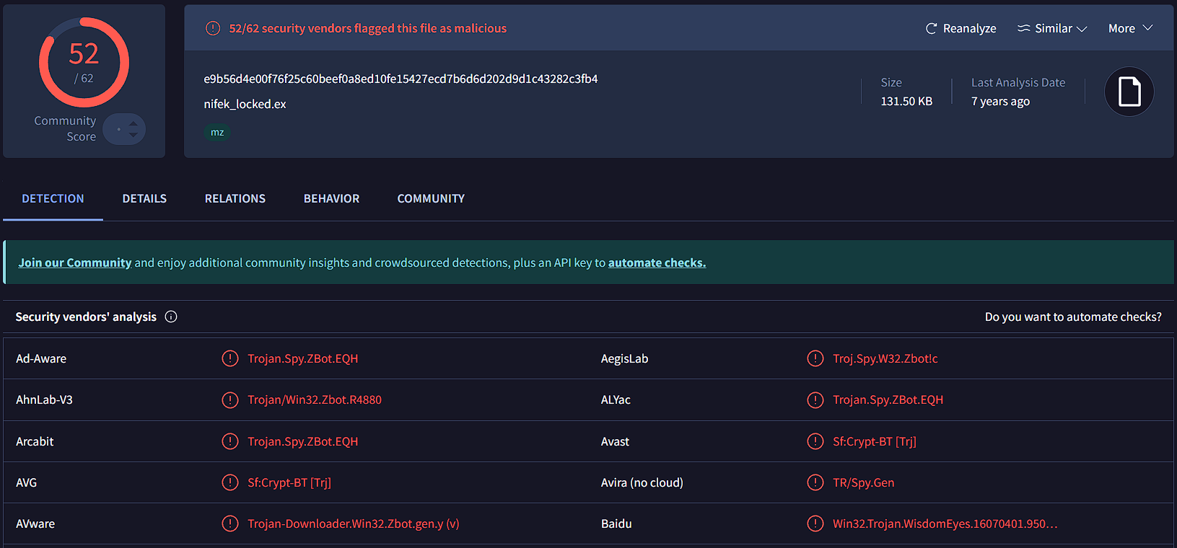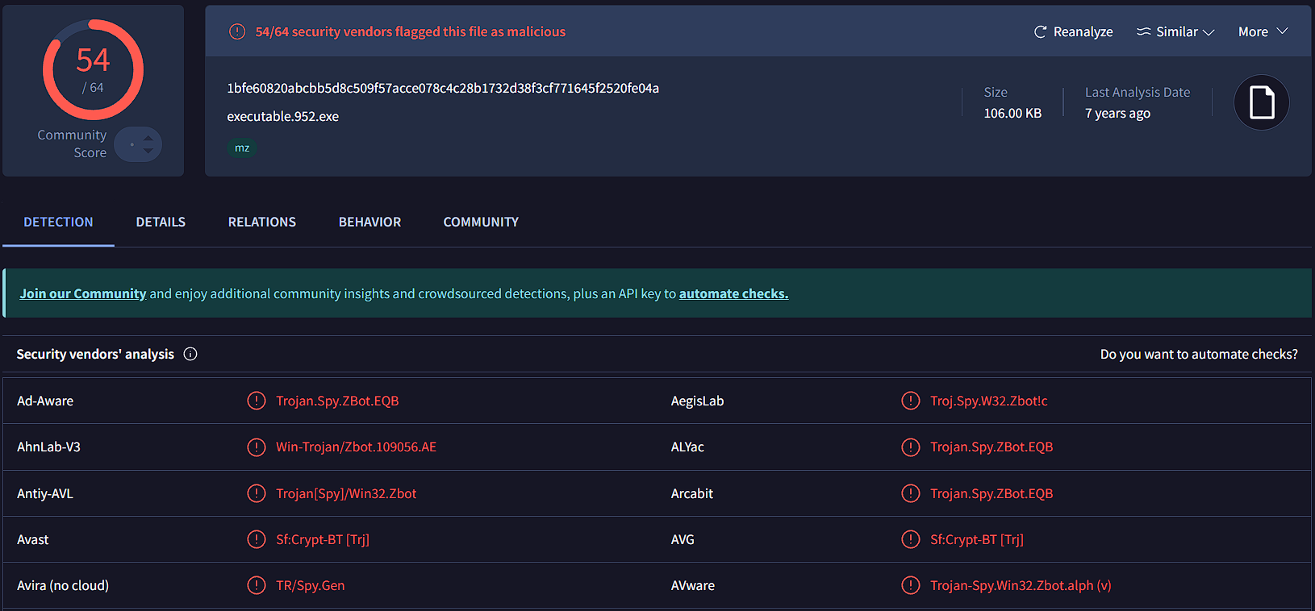

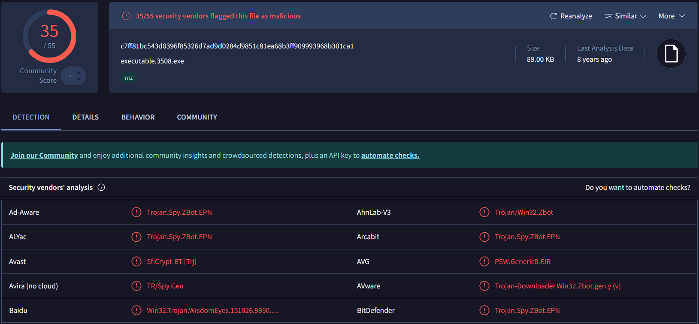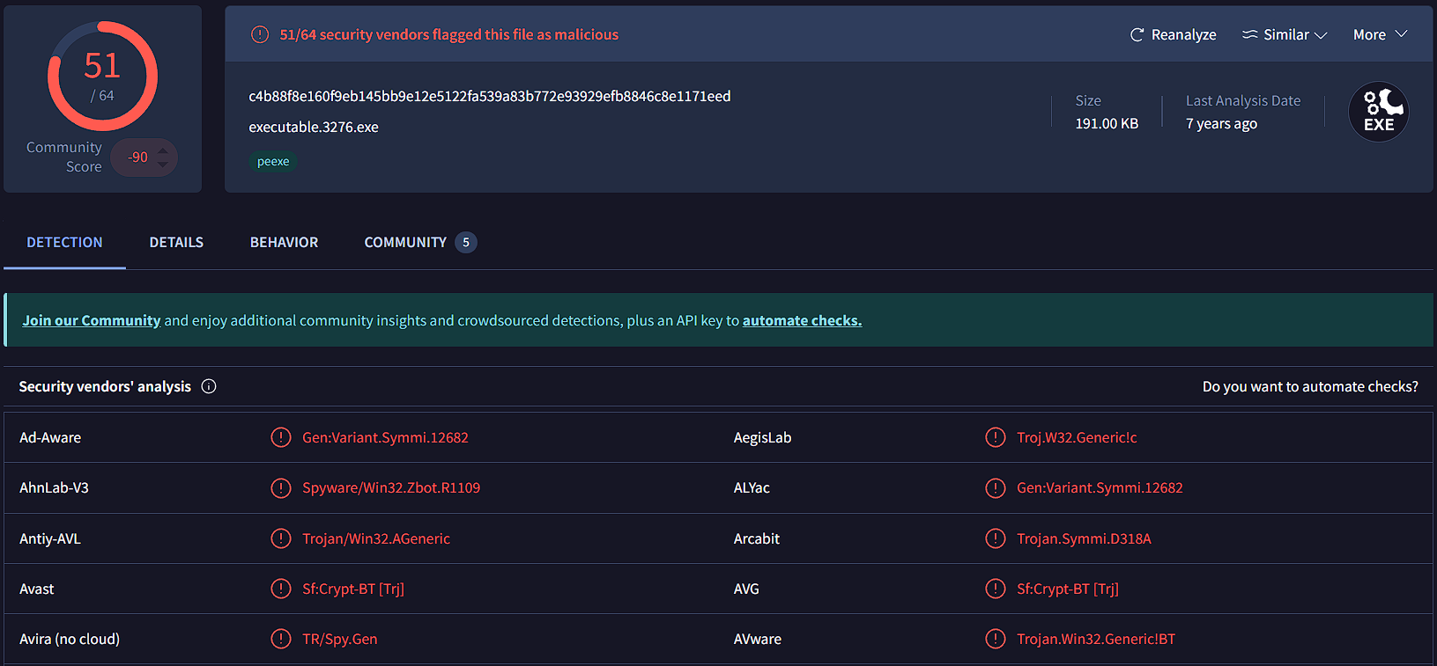

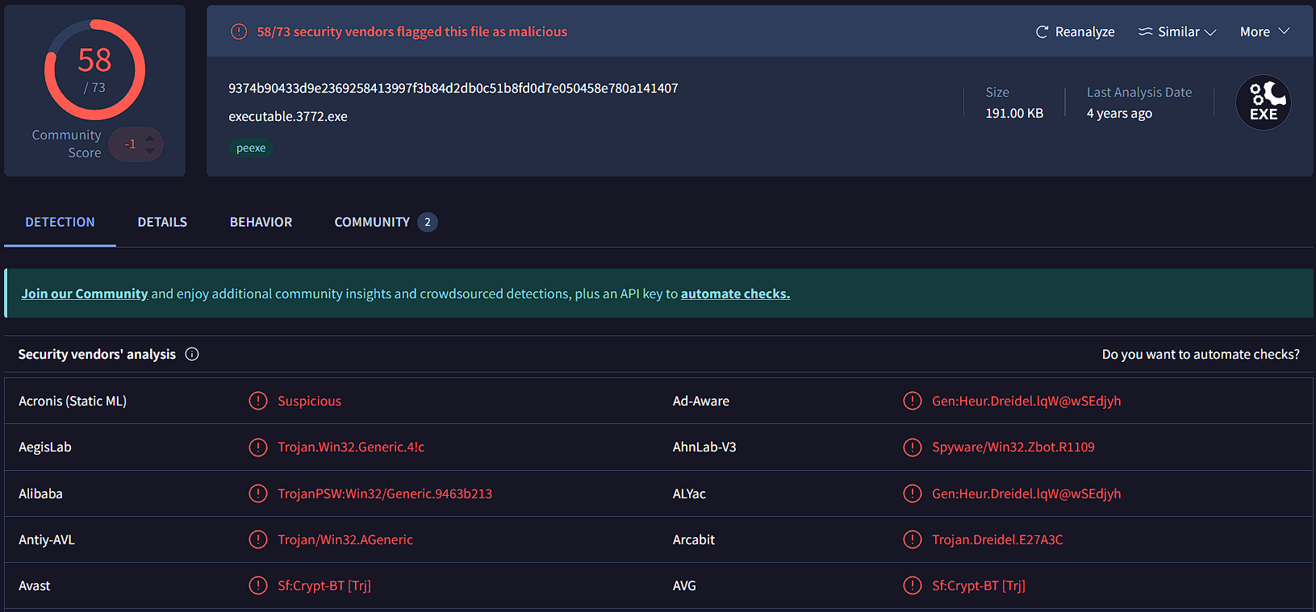

From here we can conclude that these processes are malicious. If we take a look at the Details of Process 2204, Process 3276, and Process 952 under the Names Tab we can see that it detected their names.

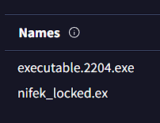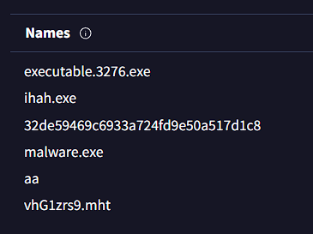

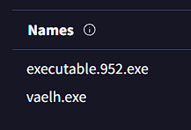

**Yara**

To use yara tool, we need to have a set of pre-defined rules called yara rules. And for that we’re going to use yarGen from previous labs. By using yarGen we’ll be able to generate our yara rules. I’ve setup yarGen before and all we need to do is generate the rules. Here we have the malware.

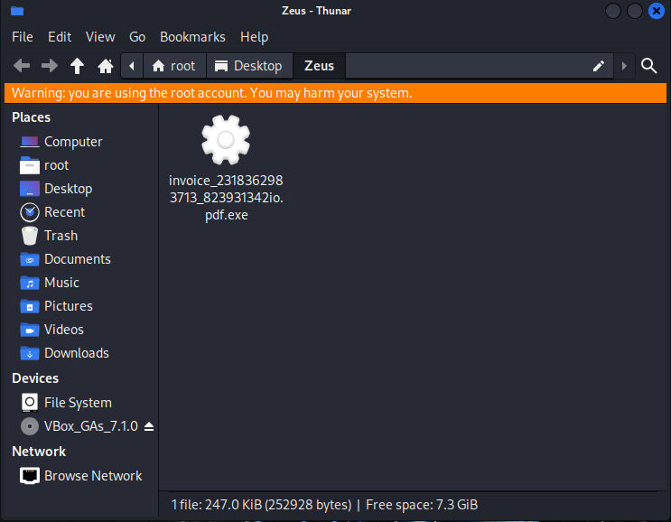

Let’s navigate to yarGen’s file path.

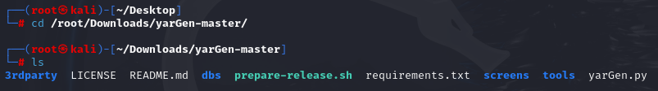

And start generating the rules.

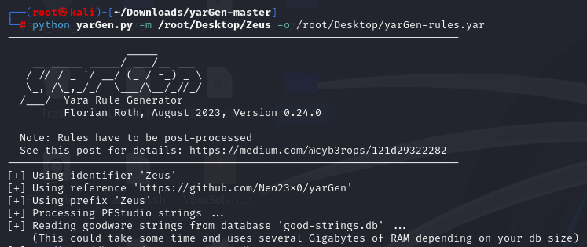

As we have our rules, now we can use yara to look for anomalies in the malware

